**CSE541 Computer Vision**

**Prof. Mehul Raval**

**Gaze Tracking**

**Week 2 Report**

| **Name** | **Enrolment Number** |
| --- | --- |
| Nityam Dixit | AU2040140 |
| Devyash Shah | AU2040152 |
| Kavan Gondalia | AU2040030 |
| Kush Patel | AU2040137 |

# Tasks Performed in the week

Selecting the appropriate camera module to IR Image of the eye, and more precisely tracking the pupil.

In last week’s process, we were able to achieve a rough outline of the pupil on a dummy video.

Which was not sufficient for the project. Also trying out with our webcam the accuracy was very low.

We dismantled an external webcam(hp w100). Which has an adjustable focus.

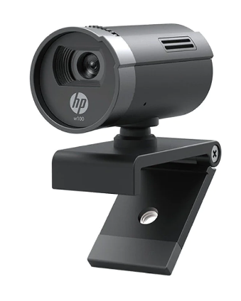

Removed the casing and IR Cut filter from above the camera sensor.

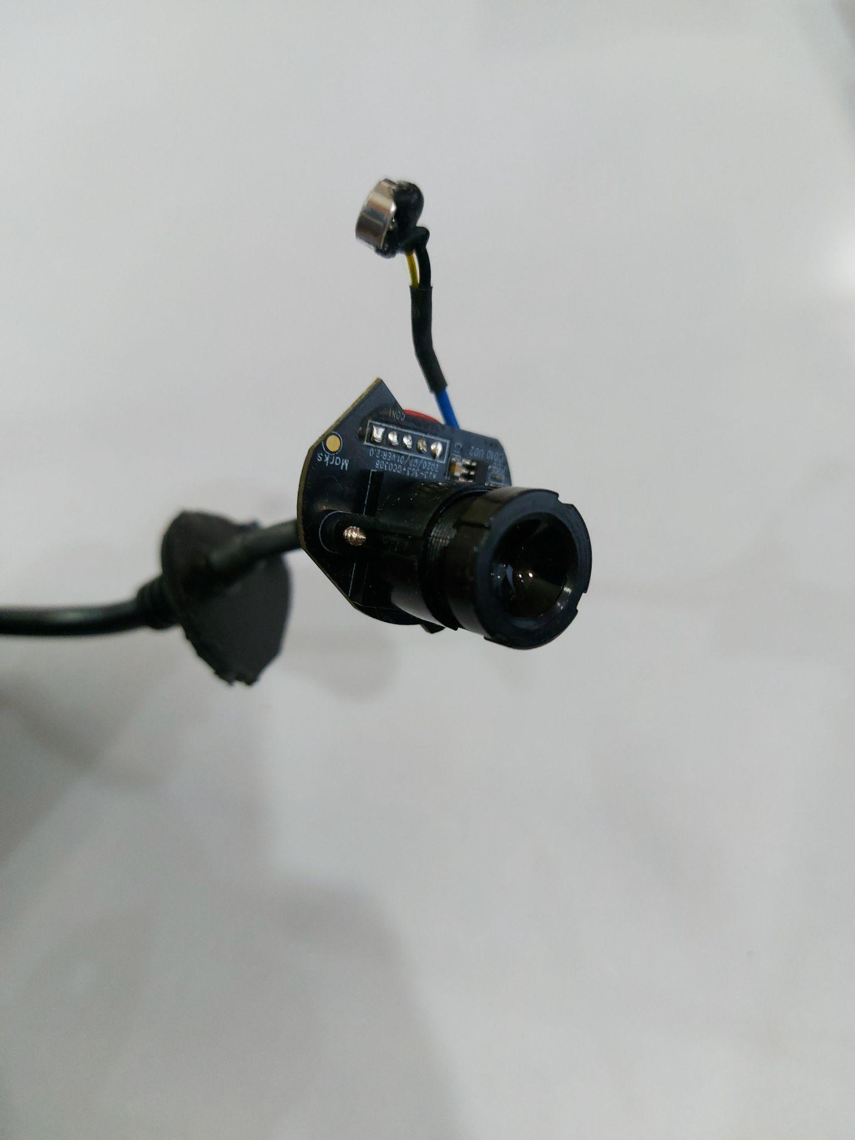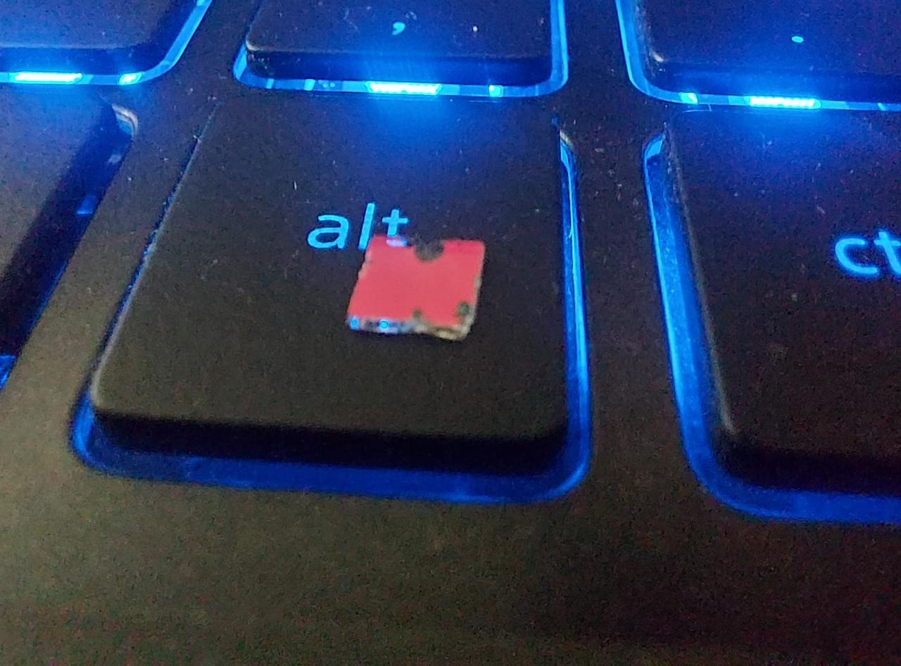

Snake model

histogram

And with that basic setup (We did not have IR Led, so we used a tv remote for testing)

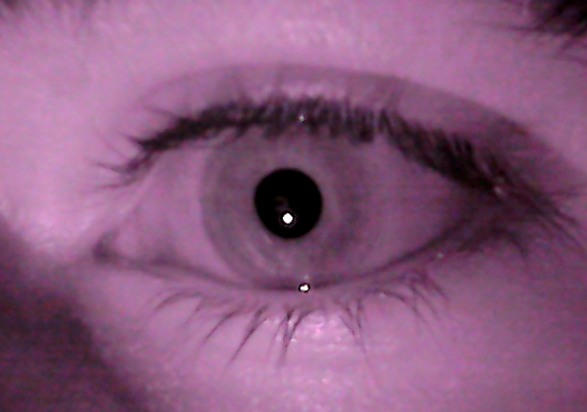

The pupil is very dark and can be simply identified with a threshold or hough-circle function.

# Outcomes of the tasks performed

Able to get IR Images from a normal computer webcam.

Processed that Image to get the pupil boundary

# Tasks to be performed in the upcoming week

Making a stand to set the camera

Calibration of the eye camera

Initial testing of the current system with cursor